Recommended First Nations Picture Books:
First Nations Traditions and Celebrations
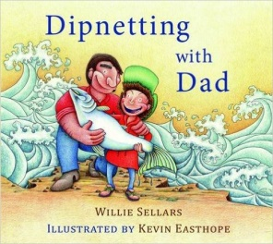
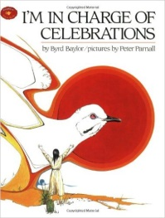
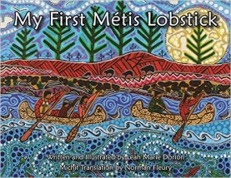

Dipnetting With Dad I’m in Charge of Celebrations My First Metis Lobstick
- Willie Sellars - Byrd Baylor - Leah Marie Dorion
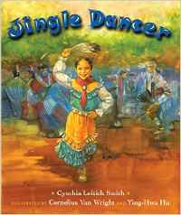
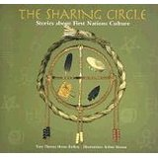
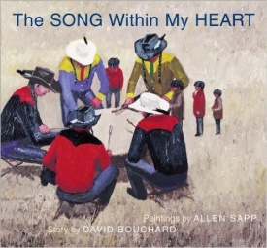

The Song Within My Heart Jingle Dancer The Sharing Circle
- David Bouchard - Cynthia Leitrich Smith - Theresa Meuse
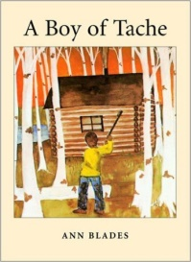
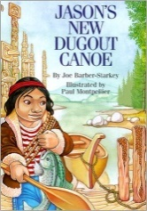
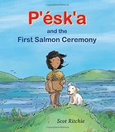

Jason’s New Dugout Canoe A Boy of Tache P’esk’a and the First Salmon
- Joe Barber-Starkey – Ann Blades Ceremony – Scott Ritchie
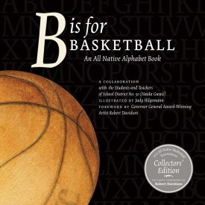
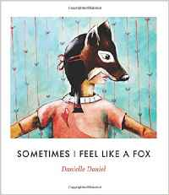
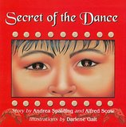

B is for Basketball Sometimes I Feel Like a Fox Secret of the Dance
– SD 50 - Danielle Daniel - Andrea Spalding

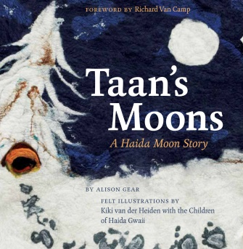  Taan’s Moons: A Haida Moon Story Alison Gear | 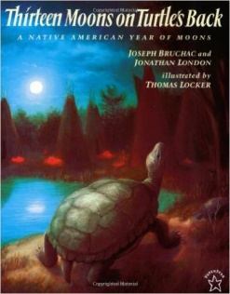  Thirteen Moons on a Turtle’s Back: A Native American Year of Moons – Joseph Bruchac | 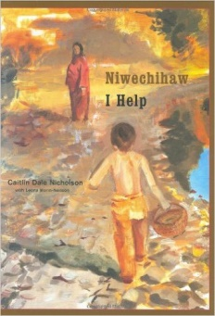  Niwechihaw I Help  Caitlin Dale Nicholson
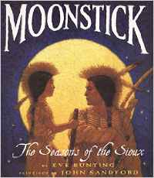  Moonsticks: The Seasons of the Sioux – Eve Bunting | 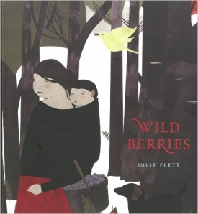  Wild Berries  - Julie Flett | 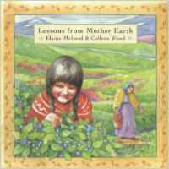  Lessons From Mother Earth Elaine McLeod
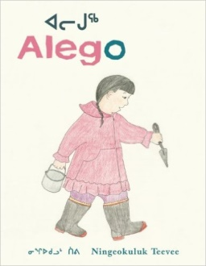  Alego  Ningeo kuluk Teevee | 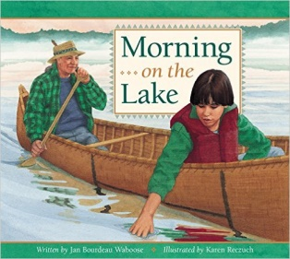  Morning on the Lake  Jan Bourdeau Waboose | A Salmon for Simon  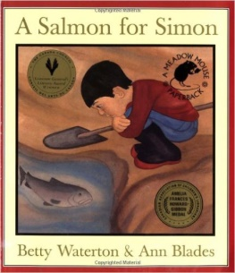  Betty Waterton
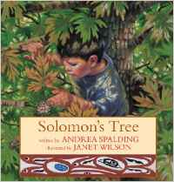  Solomon’s Tree  Andrea Spalding | 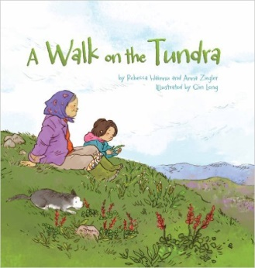  A Walk on the Tundra  Rebecca Hainnu | 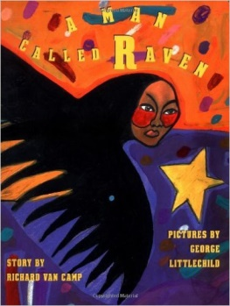  A Man Called Raven  Richard Van Camp
Respecting and Celebrating Mother Earth
First Nations Legends
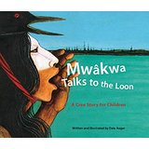  Mwakwa Talks to the Loon: A Cree Story for Children – Dale Auger  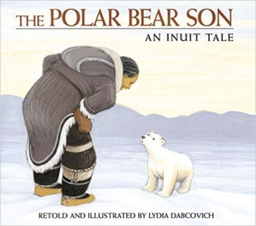  The Polar Bear Son:  An Inuit Tale – Lydia Dabcovich  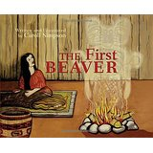  The First Beaver  Caroll Simpson  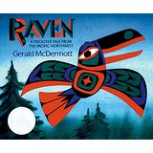  Raven: A Trickster Tale  Gerald McDermott | 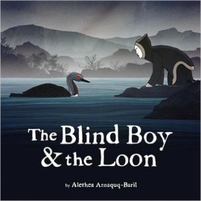  The Blind Boy and the Loon Alethea Amqueq-Baril | 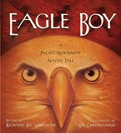  Eagle Boy  Richard Lee Vaughn  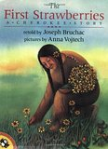  The First Strawberries  Joseph Bruchac  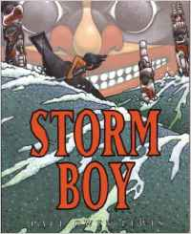  Storm Boy  Paul Owen Lewis  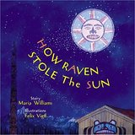  How the Raven Stole the Sun  Maria Williams
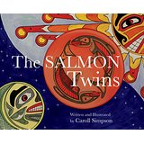
The Salmon Twins
Caroll Simpson

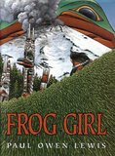
Frog Girl
Paul Owen Lewis

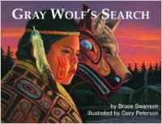
Gray Wolf’s Search
Bruce Swanson
Residential Schools/Aboriginal Injustices
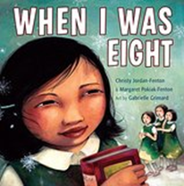  When I was Eight  Christy Gordon Fenton | 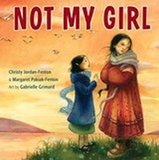  Not My Girl  Christy Gordon Fenton | 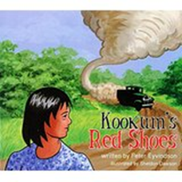  Kookum’s Red Shoes  Peter Eyvindson
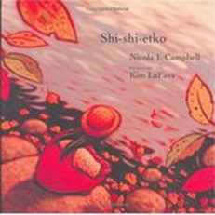  Shi-Shi-Etko  Nicola Campbell | 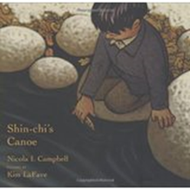  Shin-Chi’s Canoe  Nicola I. Campbell | 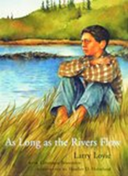  As Long as the River Flows  Larry Loyie
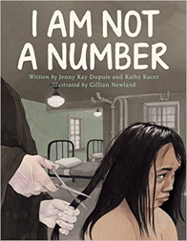  I Am Not A Number  Jenny Kay Du | 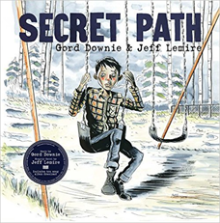  Secret Path  Gordon Downie & Jeff Lemire | 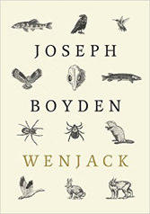  Wenjack  Joseph Boyden
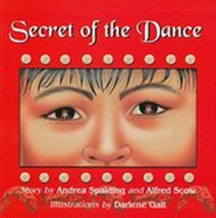  Secret of the Dance  Andrea Spalding  (Banning of the Potlatch) | 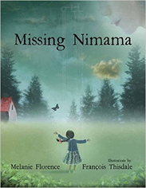  Missing Nimama Melanie Florence  (Missing Aboriginal Women) | 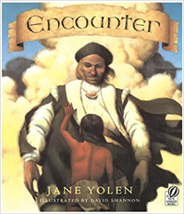  Encounter  Jane Yolen  (First contact; destruction of First Nations due to colonization)
Middle Grade Novels
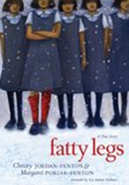  Fatty Legs  Christy Jordon-Fenton | 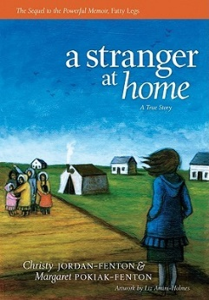  A Stranger At Home – A True Story  Christy Jordon-Fenton | 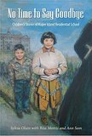  No Time to Say Goodbye  Sylvia Olsen
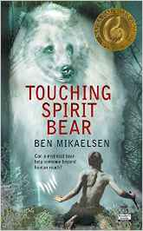  Touching Spirit Bear  Ben Mikaelsen | 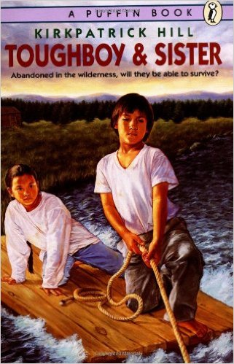  Toughboy and Sister Kirkpatrick Hill | 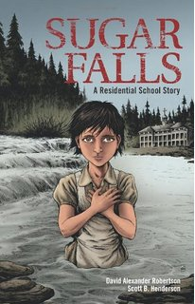  Sugar Falls: A Residential School Story  David Alexander Robertson
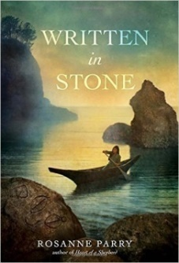  Written In Stone  Rozanne Parry | 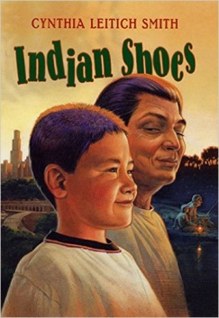  Indian Shoes  Cynthia Leitch Smith | 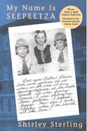  My Name is Seepeetza  Shirley Sterling
  Against the Boards  Lorna Shultz Nicholson | 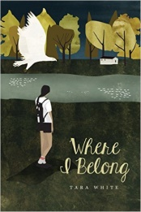  Where I Belong  Tara White | 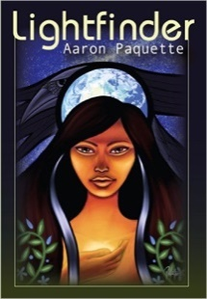  Lightfinder  Aaron Paquett

Nonfiction Books and Series
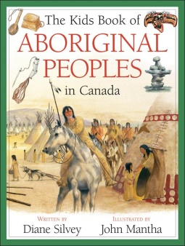  Aboriginal Peoples in Canada  Diane Silvey | 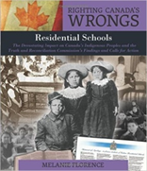  Righting Canada’s Wrong: Residential Schools  Melanie Florence | 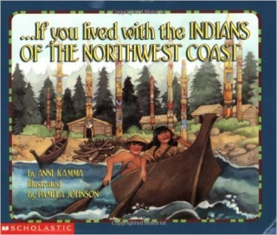  …If you lived with the INDIANS OF THE NORTHWEST COAST – Anne Kamma | 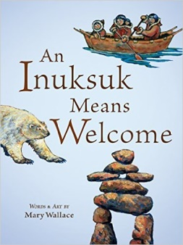  An Inuksuk Means Welcome  Mary Wallace | 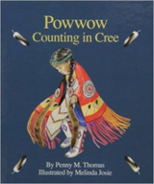  Powwow Counting in Cree Penny M. Thomas
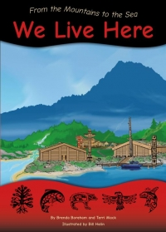
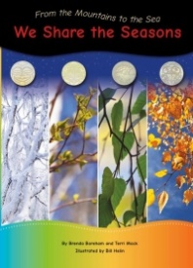
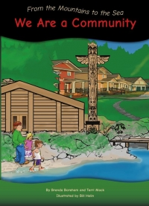
SERIES: From the Mountains to the Sea
Brenda Boreham/Terri Mack
Target audience: Early Primary
K – We Live Here
Gr. 1 – We Share the Seasons
Gr. 2 - We are a Community
Large format, colorful photographs and authentic illustrations. Each book supports new BC Aboriginal Learning Standards in Science and Social Studies.
Purchase through Strong Nations Publishing.

Aboriginal Peoples of Canada – series (gr. 2-4) - published by Weigl Educational Publishers

Includes geographical part of Canada where the people once lived and where they currently live), homes, clothing, hunting and gathering, tools (both for hunting and household use), transportation, music and dance, a legend, art, and, finally, a related activity to try (cooking and crafts).

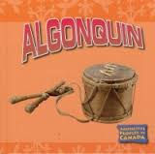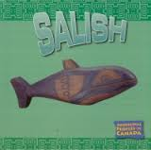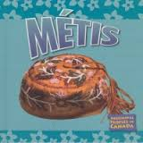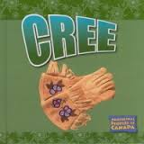

Canadian Aboriginal Art and Culture Series - published by Weigl Educational Publishers. (gr. 3-6)

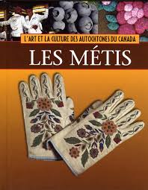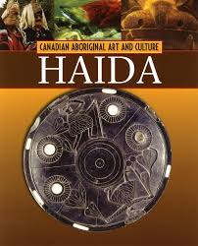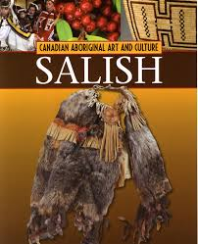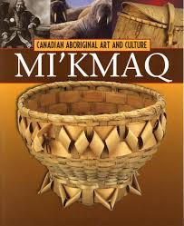
Board Books for younger readers (these make great models for older students to create their own!)

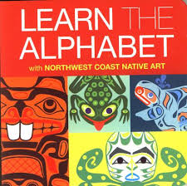  Learn the Alphabet | 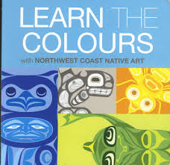  Learn the Colours | 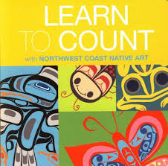  Learn to Count | 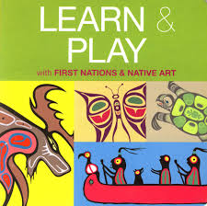  Learn & Play
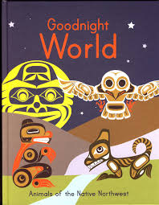  Good Night World | 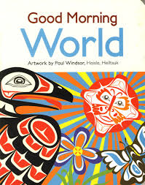  Good Morning World | 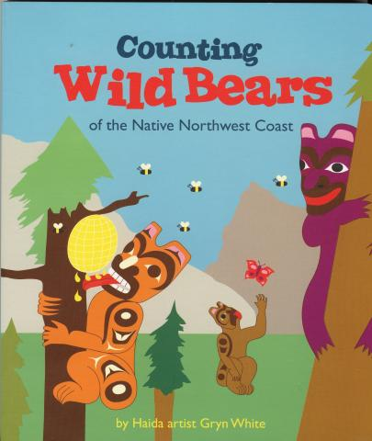  Counting Wild Bears | 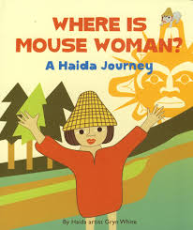  Where is Mouse Woman?
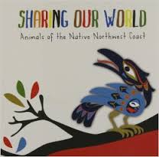  Sharing Our World- Animals of the Native Northwest Coast | 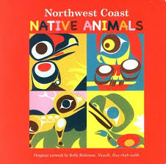  Northwest Coast Native Animals | 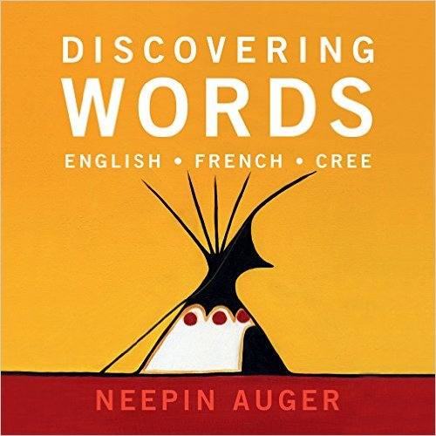  Discovering Words  ENGLISH-FRENCH-CREE  Neepin Auger | 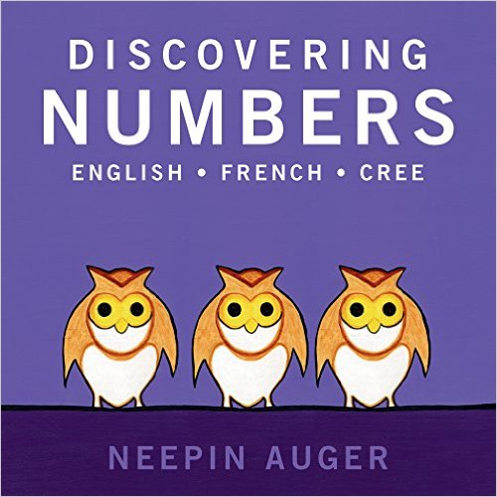  Discovering Numbers  ENGLISH-FRENCH-CREE  Neepin Auger
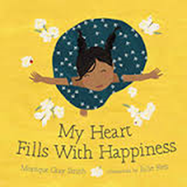  My Heart Fills With Happiness Monica Gray Smit | 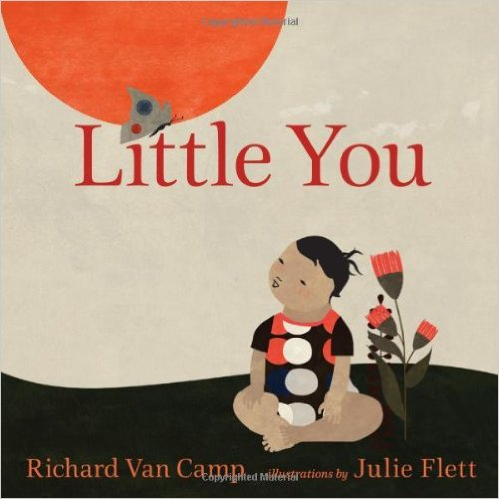  Little You  Richard Van Camp | 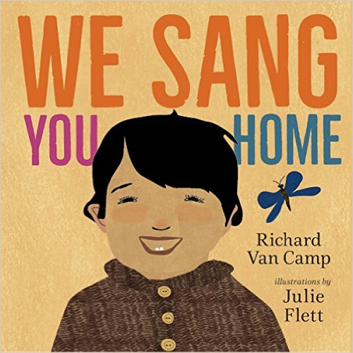  We Sang You Home  Richard Van Camp | 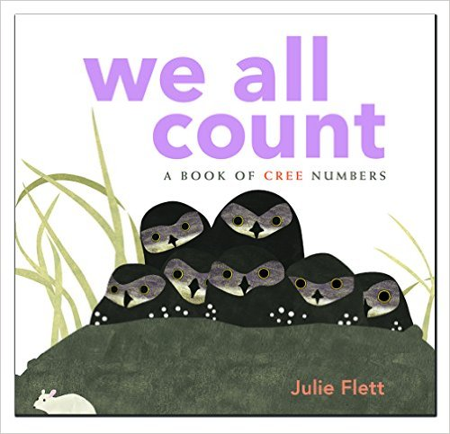  We All Count  A book of Cree Numbers  Julie Fett

ADDITIONAL RECOMMENDATIONS
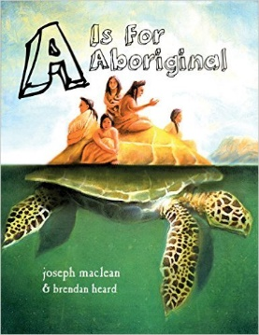
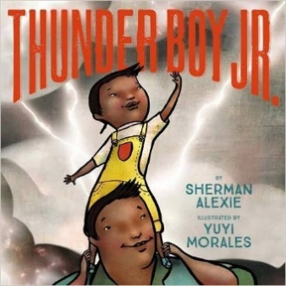

Thunder Boy Jr. – Sherman Alexie A is for Aboriginal – Joseph Maclean (Connections to names)

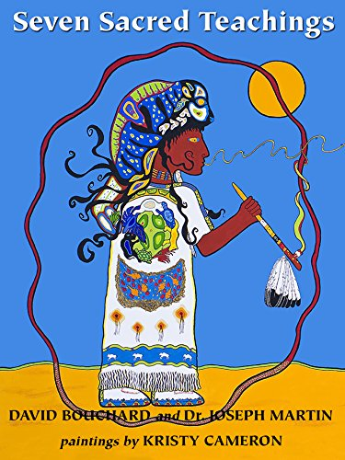
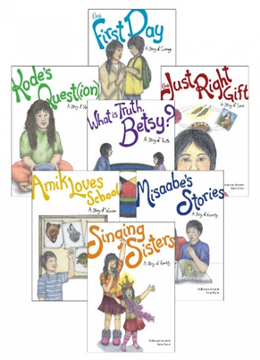

Seven Sacred Teachings – David Bouchard Seven Teachings Stories – Katherine Vermette
(also available in French)

For these titles and more, check out Strong Nations Publishing.

